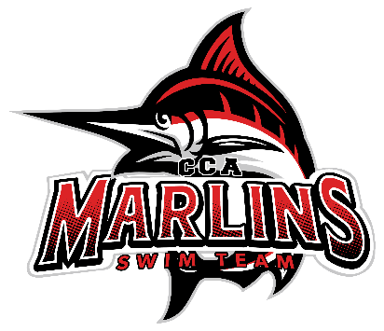

Marlins Board Meeting Minutes Recap (10/21/25)
Attendance: Brooke, Whitney, Coach Kevin, Juliet, Coach Susan, Coach Amina, Coach Buffy, Coach Jamie
1. Finances
- Julie: Financial updates will be provided via email as she is currently out of town.
2. Hiring Update
- Juliet will serve as the Board representative for the second round of interviews.
- Coaches will meet prior to the second round to discuss questions, values, and determine which coach will also participate in the interviews.
3. Coach Updates
- Coach Amina:
- The Senior group is doing great, with kids adjusting well and no issues reported.
- Goal meetings with swimmers are ongoing, and Amina has shared her personal goals with seniors to engage with younger swimmers.
-Gold group is in a pretty good rotation with Coaches Jamie, Buffy and Kevin. Not always able to provide 2 coaches on deck.
-Updated on Coach Casey’s group- this group is amazing.
- Coach Buffy:
- The Gold group is doing well, but a consistent age group coach would be beneficial. Coach Miranda is a great asset, and the kids really enjoy her.
- The Silver group is growing, especially now that fall sports have ended, with fantastic kids. The Gold group is taking the Siver kids under their wings.
- Coach Jamie:
- The Bronze group consists of hardworking kids, maxing out at 15-16 per practice. There is a lot of talent and great progress noted.
- The Gold group continues to perform well.
- Coach Susan:
- Mini Marlins are progressing and it’s exciting to see their development. While not many kids are headed to Kingsport, several will go to Christiansburg.
- Lancer Lot is fantastic with a terrific environment. Clinics on Tuesday with Coach Kevin have resulted in kids being very receptive to the program.
The new setup for swim lessons has been a total breeze.
- Coach Kevin:
-Lancer Lot Tuesdays are fantastic with the clinics; Susan’s idea for them has really engaged the kids.
- The Black group is also performing well, and attendance from Lancer Lot in Christiansburg should be good.
-Gold group is an amazing group with really hard workers.
4. Swim-a-thon Conversation
- Discussion included planning for snacks and prizes for the event.
5. Anything Else
- Coach Susan and Amina: Discussed a monogram project for coaches.
- Discussion on a Swim Across America fundraiser idea.
- Holiday Party: Scheduled for December 15 at Explore Park (Illuminights).
- Team Pictures: Plan for December 15.
- Coaches Amina, Susan, Buffy, and Kevin will attend the Kingsport meet.
Next Meeting: Scheduled for November 18, 2025, at 8:30 PM (virtual).

